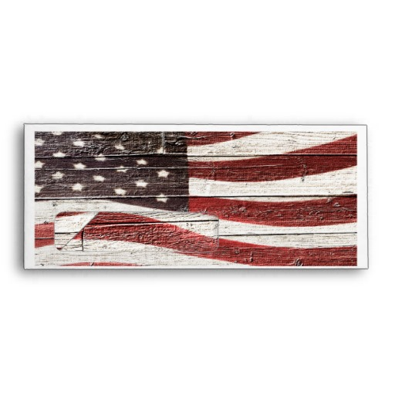

**The National and Kapodistrian University of Athens**

**School of Philosophy**

**Faculty of English language and Literature**

**Invites you to:**

**American Textures**



**American Contrasts**

**Wednesday, 14 May 2014**

**12:00 -17:00**

**Athens University Museum**

**Tholou 5, Plaka**

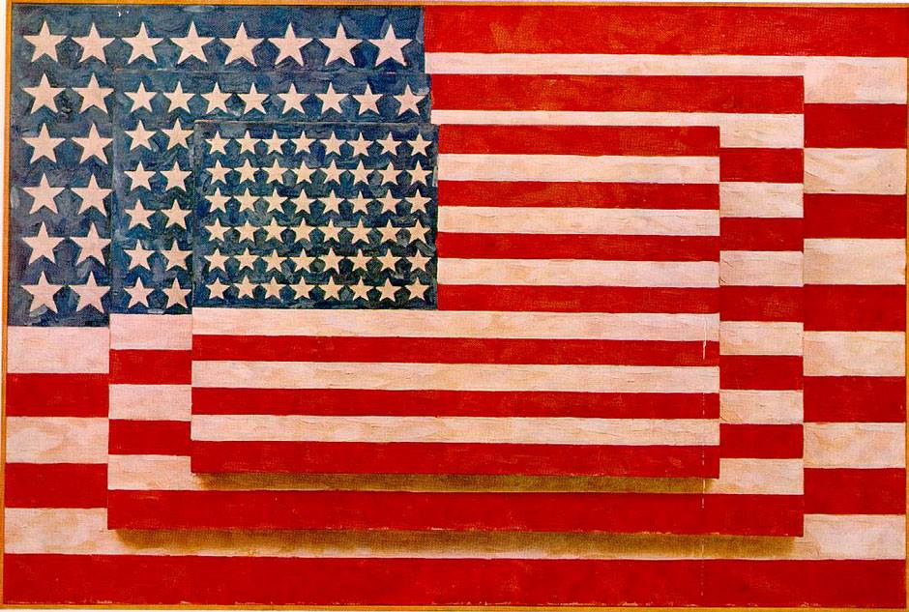

**HowardCaygill**, **KingstonUniversity**

**Old and New Worlds in David Lynch’s *Inland Empire***

**Winfried Fluck, FreieUniversität**

**American Studies and the Realities of America**

**Angeliki Tseti, University of Athens**

**Acting out the (American) crisis: Photo-textuality and the “outlandish stranger” in Aleksandar Hemon's *The Lazarus Project***

**Maria Pyrgerou, University of Athens**

**Arthur Miller's *The Crucible*: Constructing the Other-- Deconstructing American Political Subjectivity**

**David Rudrum, University of Huddersfield**

**New Yet Unapproachable: Visions of America in Arthur Miller and Stanley Cavell**